Please follow this template structure and style headings. Refer to author guidance notes on Page 2 and the submission checklist on Page 3.

Insert title of paper here

Name of first author, affiliation
Name of second author, affiliation

Abstract
The abstract should be long enough that it is meaningful to readers, but not too long (circa 200 words)

Notation
Insert symbols and notation here.

First-Level Section Heading
Use paper text style (11pt Arial).

Second-level heading
Use paper text style (11pt Arial)

Acknowledgments

References

Guidance on format
This section contains guidance on the formatting of the paper. Please use the styles available within the template.

Paragraphs
Leave one line space between paragraphs.

References to equations and figure
References to figures should be made with the word Figure capitalised e.g. see Figure 1.

References to equations should be made with the word Equation capitalised e.g. it follows from Equation (1) that …….

Equations
Equations should be numbered sequentially (1), (2), with the number positioned on the right hand side of the page. Equations should be centred. e.g.

An elemental length of the plated beam is shown in Figure 3. Considering equilibrium of the plate element,
(1)

Differentiating Eqn. and substituting Eqn. gives,

(2)

Figures
Figures should be centred on the page and captioned.

Figures should be included within the body of the paper rather than at the end.

Figures can be submitted in colour.

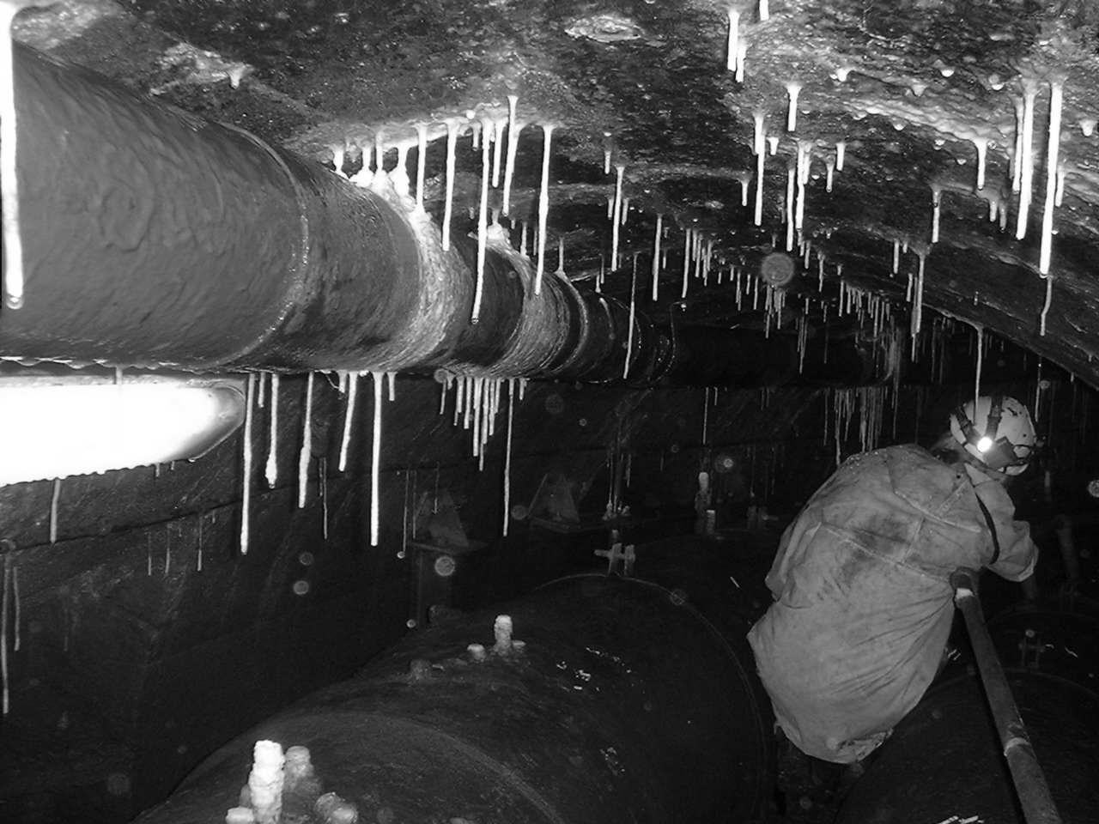
Figure Caption: e.g. Figure 1. Tunnel deterioration

Continue paper text…

Acknowledgements
Be sure to include acknowledgement to those who have contributed to the work and relevant BSi committees etc.

References
References should be numbers and referred to in the text by the reference number using superscript^{[1],[2]}. They should use the “reference” style

[1] Kofoed, V.O, Montgomery, J and Gardiner, K.D. (2006). Identifying Leakage Paths in Earthen Embankments. Proceedings of 14th Conference of the British Dam Society – Thomas Telford Ltd
[2] Quayle, T (2006) Manchester’s Water – The Reservoirs in the Hills. Tempus.
[3] Quayle, T (editor) The Bateman Reports 1846 to 1865 – Unpublished.
[4] Bateman, J.F La Trobe (1884) History and Description of the Manchester Waterworks – Spon

Further Guidance
Further guidance can be found here: Author Guidelines for the Technical Papers Competition - HS2 Learning Legacy

Checklist before submission:
- Is there sufficient background and industry context
- Is there a sufficient level of detail in the paper for this to be transferable learning for future projects or programmes?
- Is evidence provided to support the learning outcomes?
- Is the learning legacy explicitly set out in both the abstract and the Conclusion?
- Have you followed the style guide:
  - Please make your text as short and concise as possible, excluding anything that is not directly relevant to the subject.
  - The text should be in UK English, in the third person and should be readily understandable by another project professional person.
  - Please avoid unnecessary use of the masculine gender where it is not required.
  - Use bullet points rather than numbers or letters for lists.
  - Please do not refer to the names of individuals, organisations, products or services unless it is essential to understanding your submission. You should not be gratuitously complimentary or in any way derogatory about any person or organisation either directly or implied.
  - Please include legible graphs, photographs and/or drawings, not just text. Files should be uploaded in the format that they were originally created in.
- Has each author completed an author consent form: https://www.smartsurvey.co.uk/s/OMNW3V/

Submitting your paper
Guidance on how to submit your paper can be found here:

